**Tutorial 2:**

In this tutorial i tried to perform union and intersection operations on texts. I took two files consisting of friends list of two persons. By intersection operation I can find the mutual friends and by union operator I can find the total number of friends and by using distinct function I can eliminate the duplicates in the union list

**Input:**

Ganesh’s friends list

Ganesh  
Abhinay  
Sachin  
Obama  
Micheal  
Harry  
Sarah

Sachin’s friends list

Sarah  
Ganesh  
Sachin  
Abhi  
Ganguly  
Dravid  
Sridhar  
Aruna

**Output:**

Mutual Friends list:

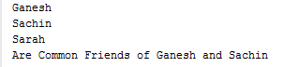

Total Number of Distinct friends:



Some more actions on the list:



